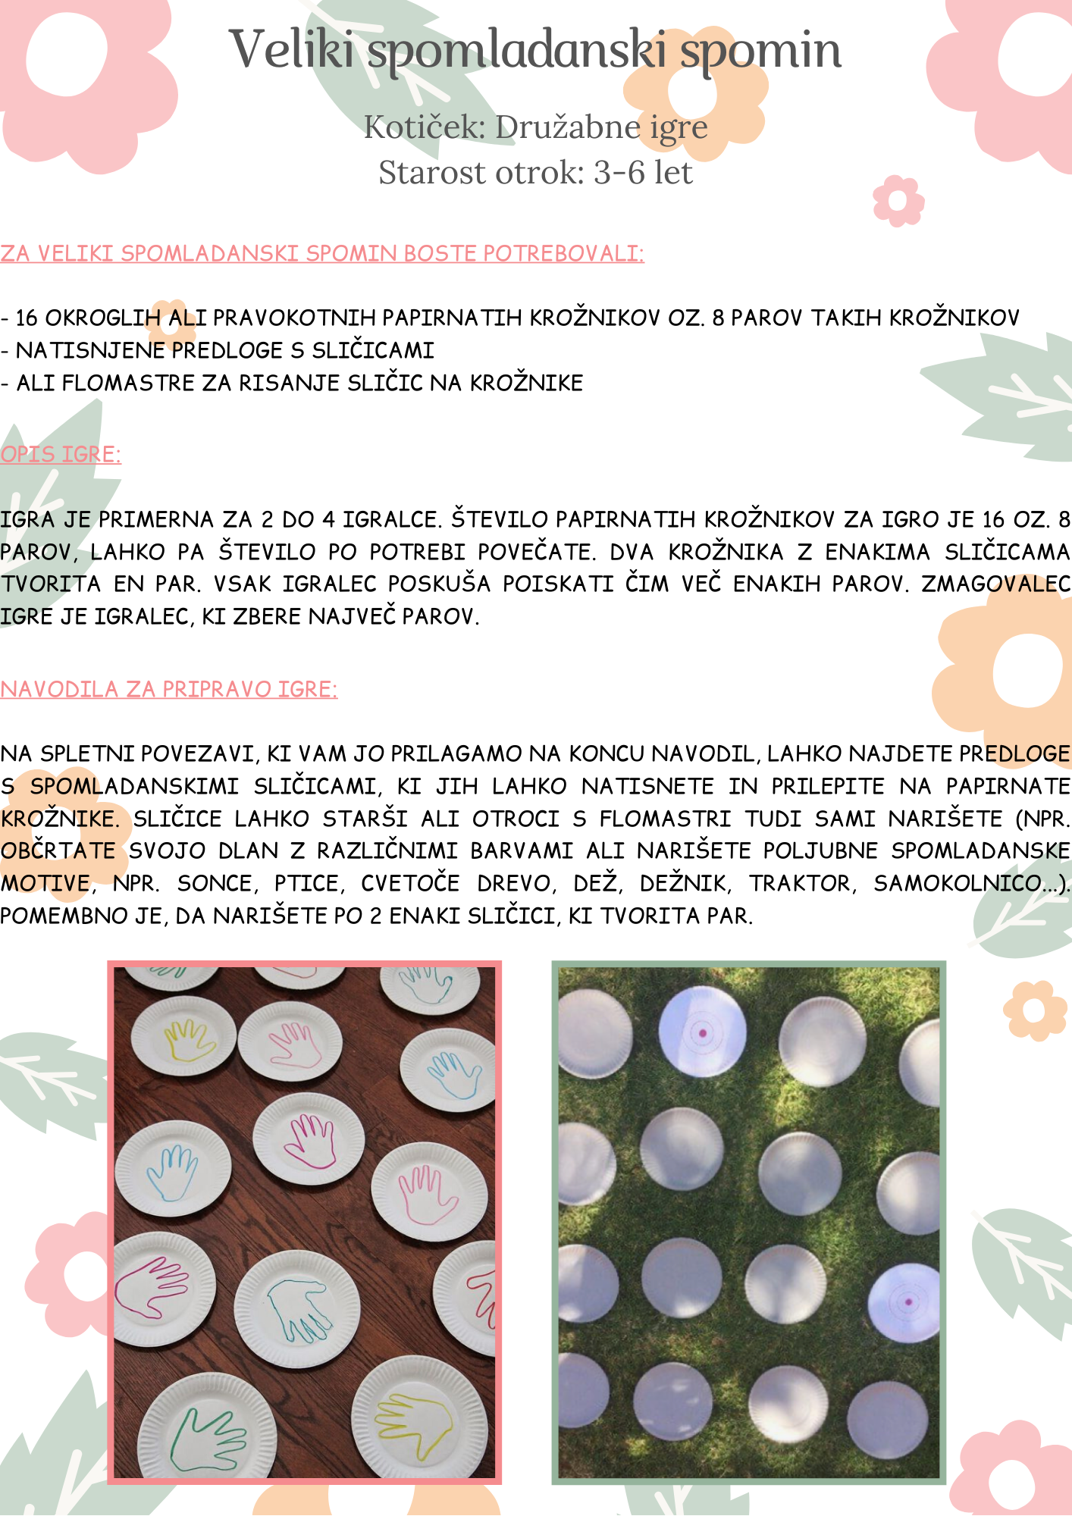

POVEZAVA DO SPLETNE STRANI S PREDLOGAMI:

<http://www.3dinosaurs.com/printable/spring-pack>

VIRI:

- http://www.pinterest.com

- http://www.3dinosaurs.com/

